**ESP-IDF Develop with VSCode Plug-in**

Index

[Install VSCode 2](#_Toc10945)

[Install Espressif IDF Plug-in 3](#_Toc30786)

[Install Espressif IDF 3](#_Toc14304)

[Install Espressif IDF Plug-in 6](#_Toc32277)

[Official Demo(VIEWE) 15](#_Toc25595)

[Download Demo 15](#_Toc29096)

[Modify COM Port 18](#_Toc4020)

[Modify the Driver 20](#_Toc4300)

[The Rest of the Status Bar Introduction 24](#_Toc10879)

[Compile, Program, and Serial Port Monitoring 26](#_Toc14944)

[Software 29](#_Toc6140)

# Install VSCode

1. Open the [download page](https://code.visualstudio.com/download" \t "_blank) of the official VSCode website, and select the corresponding system and system bit to download.

[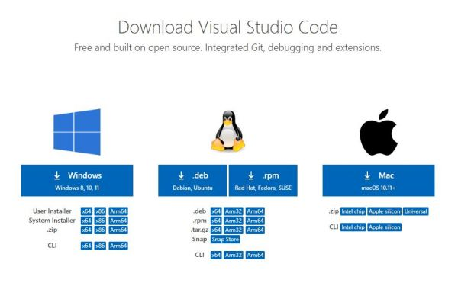](https://www.waveshare.com/wiki/File:ESP32-S3-Pico_05.jpg)

2. After running the installation package, the rest can be installed by default, but here for the subsequent experience, it is recommended to check boxes 1, 2, and 3.

* After the first and second items are enabled, you can open VSCode directly by right-clicking files or directories, which can improve the subsequent user experience.
* After the third item is enabled, you can select VSCode directly when you choose how to open it.

[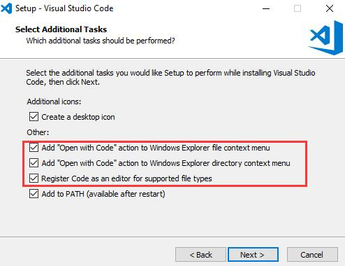](https://www.waveshare.com/wiki/File:ESP32-S3-Pico_06.jpg)

# Install Espressif IDF Plug-in

## Install Espressif IDF

1. *Click [here](https://dl.espressif.cn/dl/esp-idf/?idf=4.4) to download Espressif IDF and select ESP-IDF v5.2.2-Offline.as shown in the following figure:*

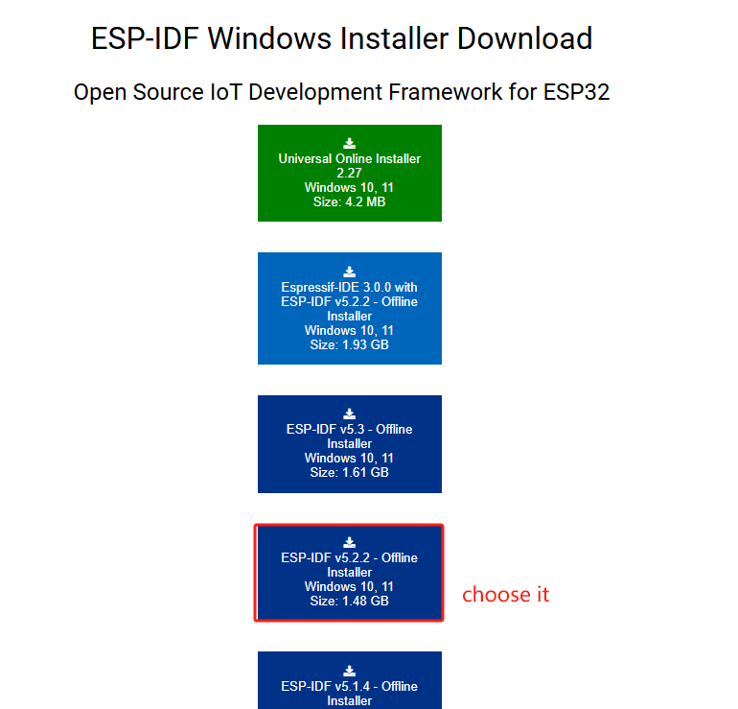

1. *Installation: REMEMBER your own installation path when installing. The path in the following explanation is based on my installation as an example, and the corresponding path can be mentioned. You can also be the same as me.*
   1. *choose language*
   2. *agree with the protocol*
   3. *Please pay attention to the following screen:*

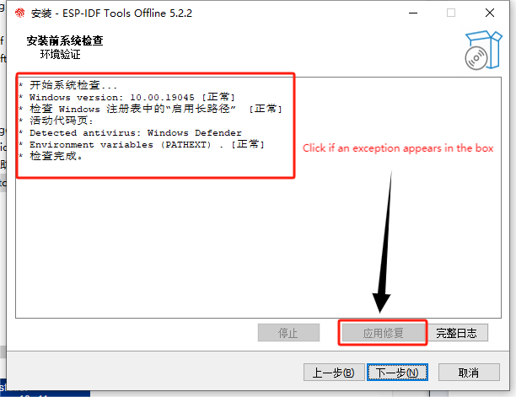

* 1. *My installation path: D:\esp-idf (You can decide your own path)*
  2. *The rest is the default next step*
  3. *Wait for the installation, the following two Windows appear to indicate that the installation is completed, they are essentially the same, if you only compile in VSCode, you will rarely use it in the later stage.*

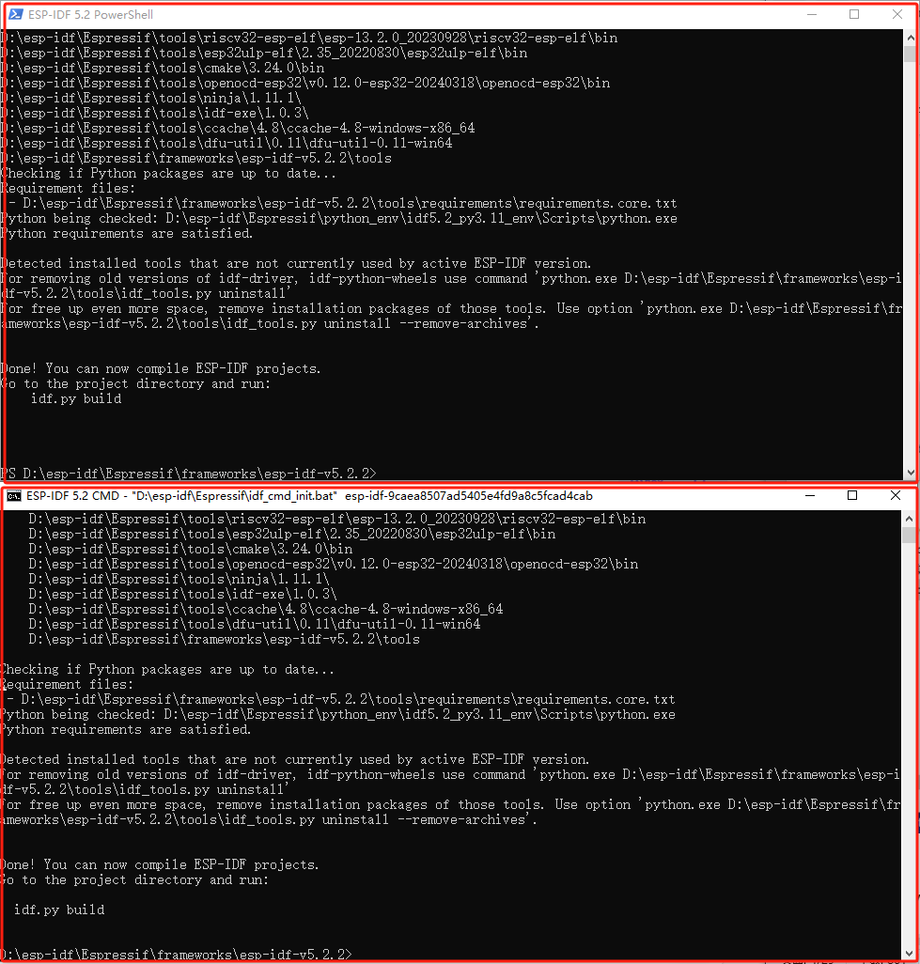

## Install Espressif IDF Plug-in

*Note: The latest version of the current plug-in is V1.8.0, for a consistent experience, users can choose the same version as us.*

1. Open VSCode and use the shortcut key Shift + Ctrl + X to enter the plugin manager.

[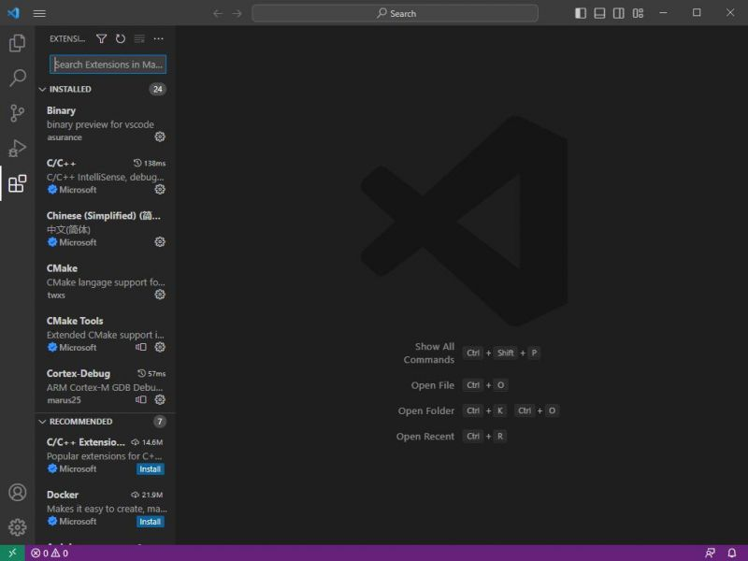](https://www.waveshare.com/wiki/File:ESP32-S3-Pico_07.jpg)

1. In the search bar, type Espressif IDF, select the corresponding plug-in, and click install.

[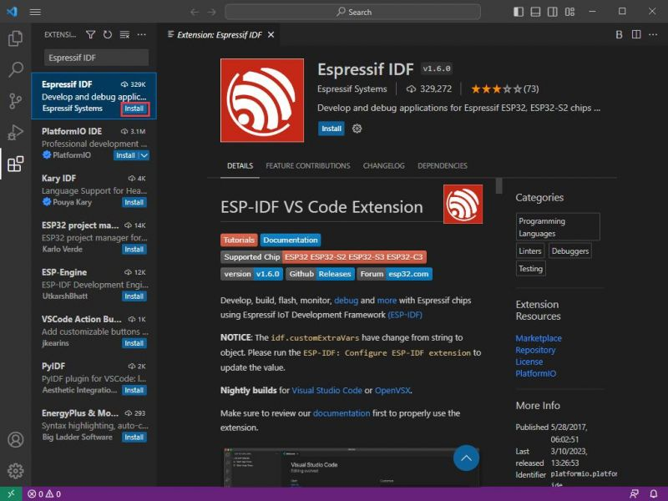](https://www.waveshare.com/wiki/File:ESP32-S3-Pico_08.jpg)

1. Press F1 to enter:

esp-idf: configure esp-idf extension

[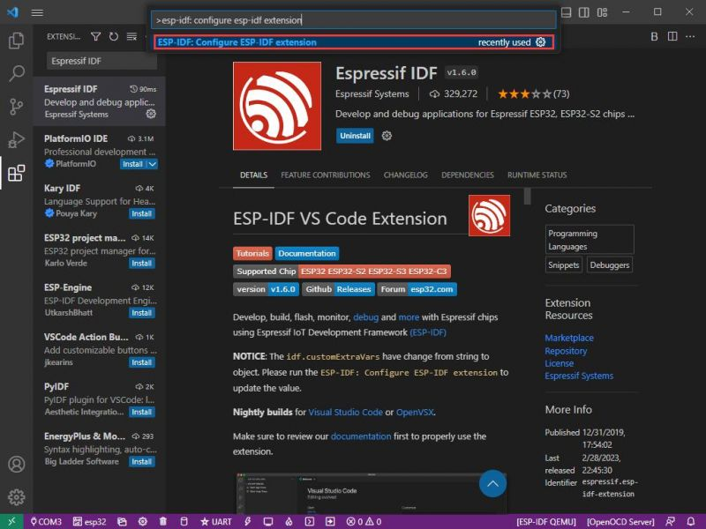](https://www.waveshare.com/wiki/File:ESP32-S3-Pico_09.jpg)

4. Choose express (This tutorial is for first-time users, so only the first general installation tutorial is covered.)

[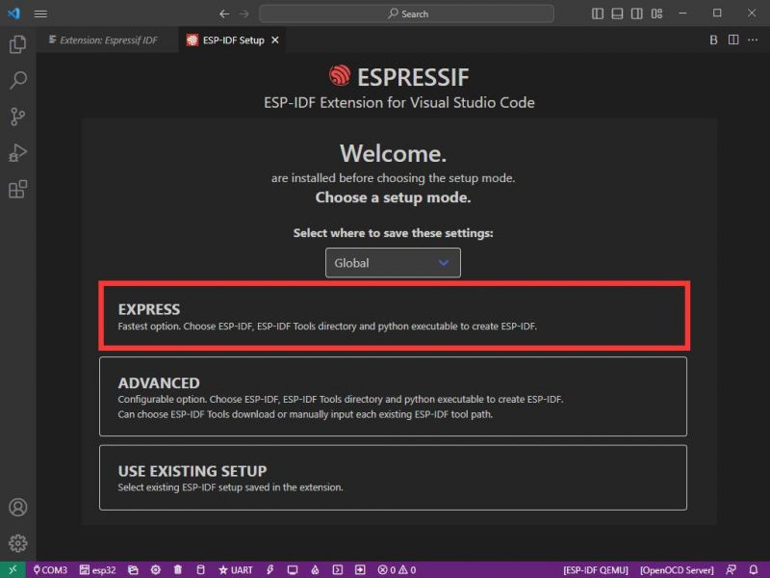](https://www.waveshare.com/wiki/File:ESP32-S3-Pico_10.jpg)

5. Open and display this screen.

[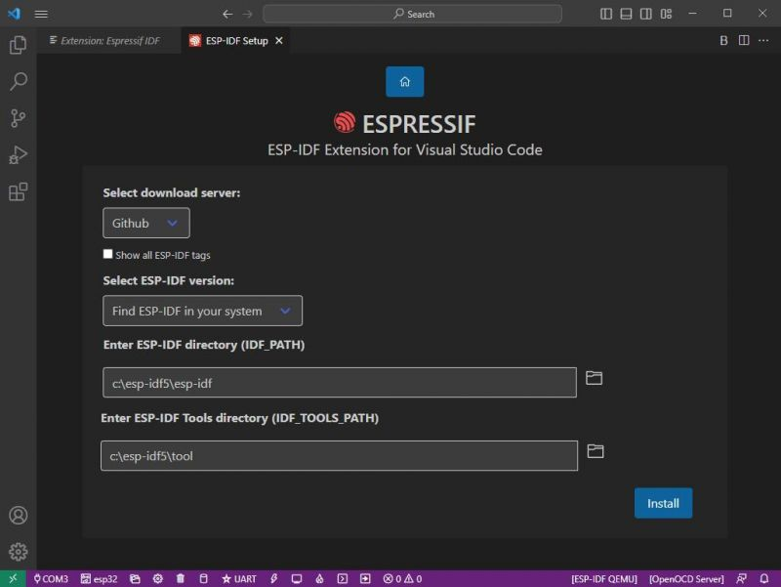](https://www.waveshare.com/wiki/File:ESP32-S3-Pico_11.jpg)

6. Choose a server to download.

[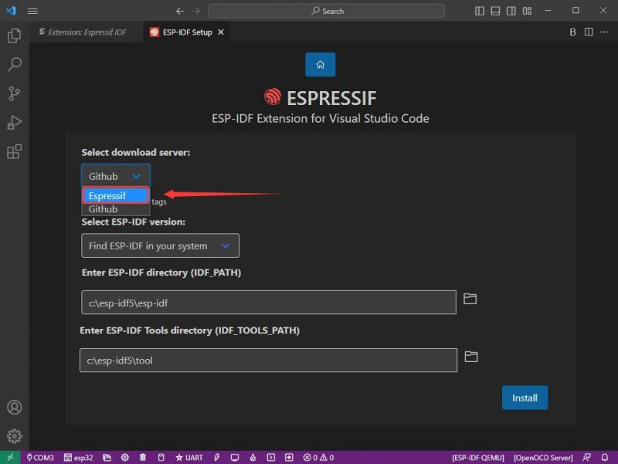](https://www.waveshare.com/wiki/File:ESP32-S3-Pico_12.jpg)

7. Select the ESP-IDF version you want now, we choose the latest V5.3 (note that ESP-IDF started to support ESP32-S3 only after V4.4).We've got it installed so we're going to Find ESP-IDF insystem.

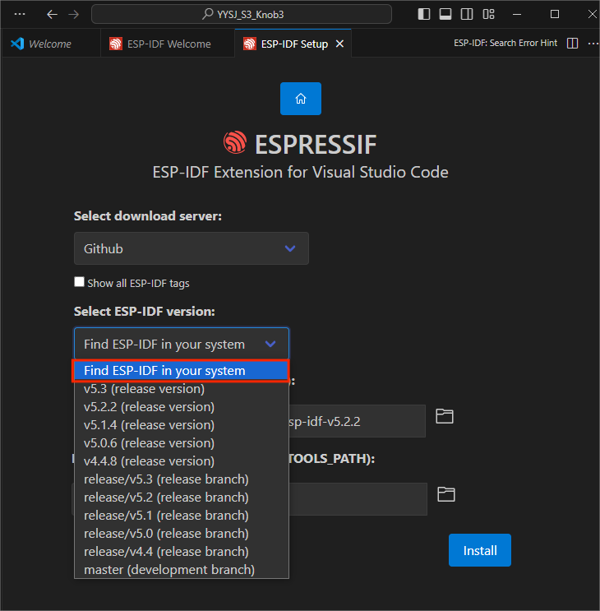

8. The following two are the ESP-IDF directory installation address and the ESP-IDF required tools installation address respectively.

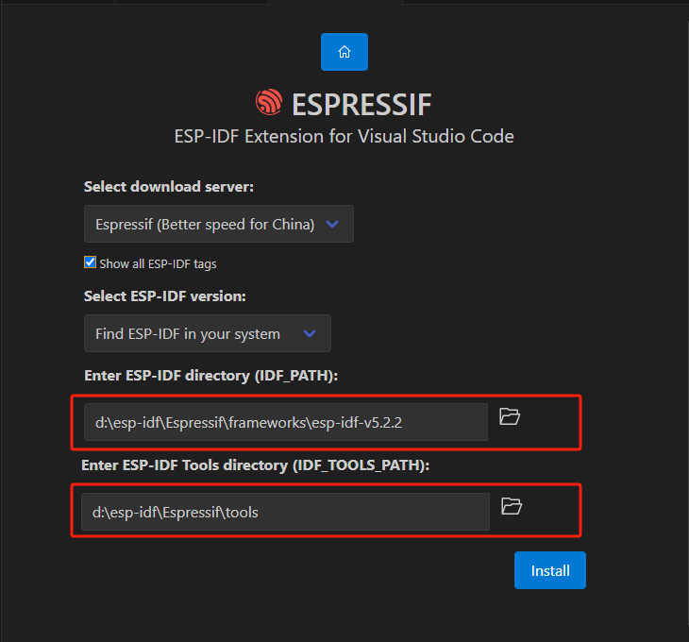

*Note: If you have installed ESP-IDF before, or if it has failed, please make sure to delete the file completely or create a new path.*

9. Once the configuration is finished, click "install" to download. (After clicking, it takes a while to configure and install)

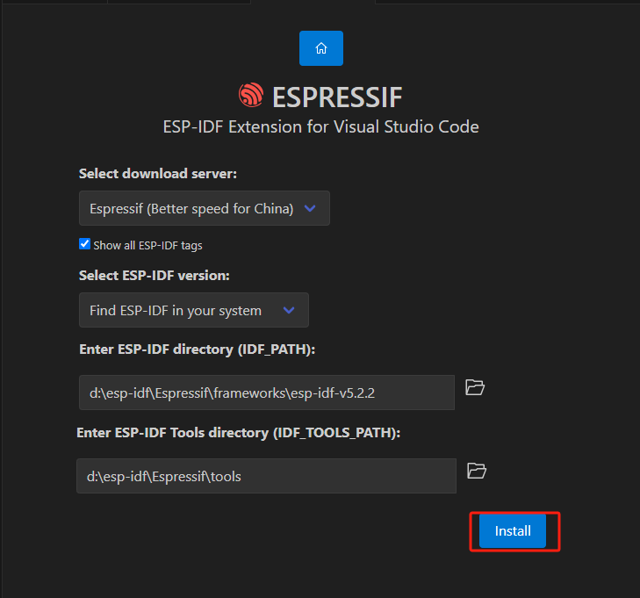

10. After the installation is completed, it will enter the following screen, indicating that the installation is finished.

[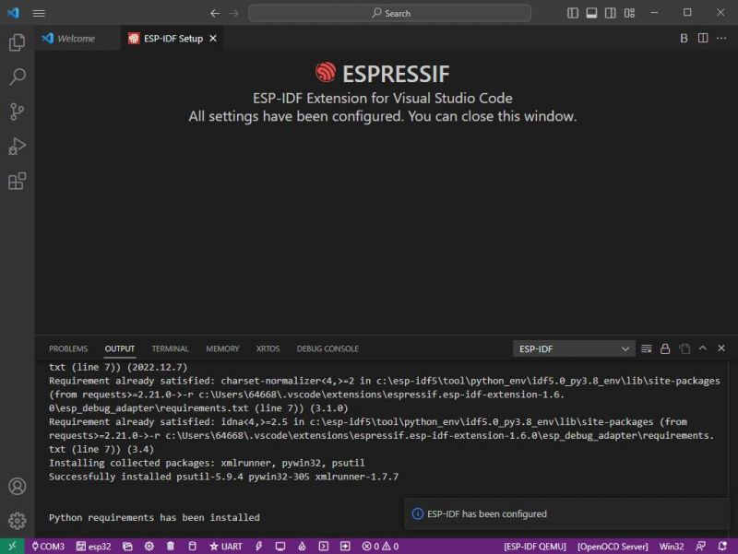](https://www.waveshare.com/wiki/File:ESP32-S3-Pico_17.jpg)

# Official Demo(VIEWE)

## Download Demo

1. Click [here](https://github.com/VIEWESMART/ESP32-IDF/tree/main/examples) to select the demo corresponding to your development board to download.
2. To download a specific folder from the GitHub web page, use the following method:
   1. Use third-party tools to download the specified folder
   2. If you only want to download specific folders and don't want to download the entire repository, you can use a third-party tool like DownGit:
      1. Access DownGit:

* Open the DownGit website.Click [here](https://downgit.github.io/" \l "/home).
  + 1. Enter the folder URL:
* Go back to the GitHub repo page and navigate to the folder you want to download.
* Copy the URL from your browser's address bar.
  + 1. Generate the download link:
* Go back to the DownGit page and paste the copied URL into the input field.
* Click the "Download" button.
  + 1. Download the folder:
* DownGit will generate a link that you can click to download directly to the folder you specify.

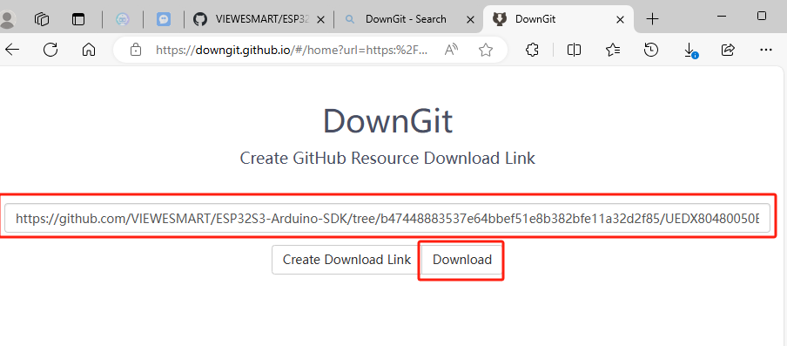

1. To avoid compilation errors, after downloading, we usually put the project in the following folder, corresponding to their installation path to it, and put the project files in it, and the future ESP-IDF framework projects are put in it.

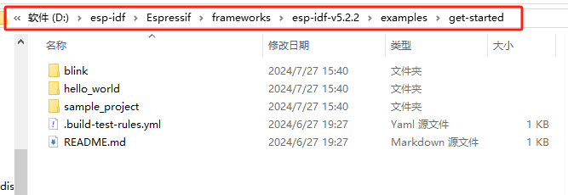

1. Open the project with VSCode, or just drag and drop it with VSCode.It opens as shown below:

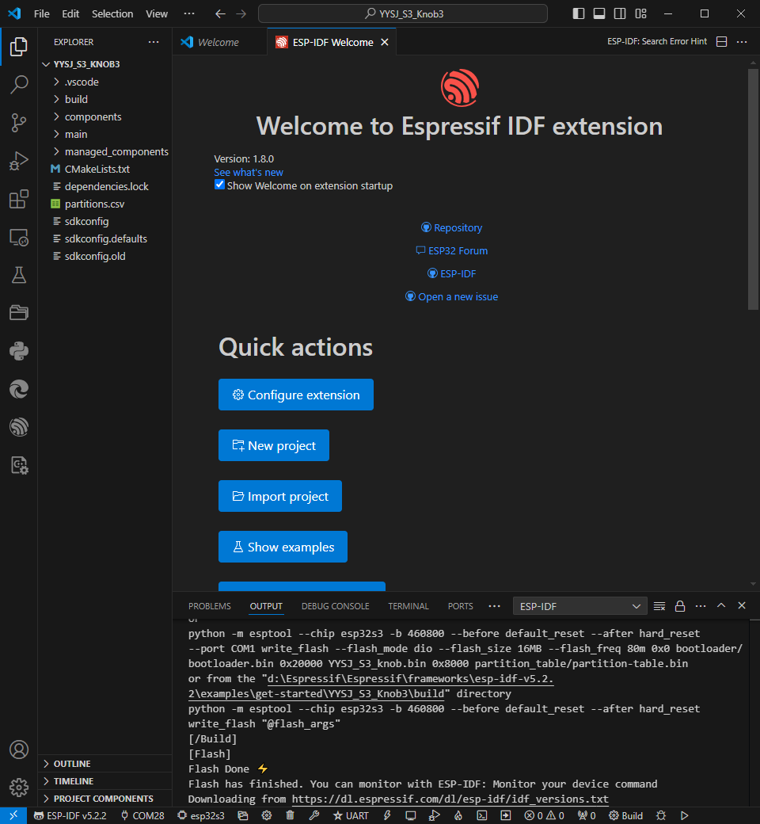

## Modify COM Port

1. Hardware link method (Install USB to serial port tool before this.Select the appropriate version according to your system.[Click here](#_Software))
   1. After installation, when you plug in the board and look at the device manager in computer management.Ports similar to the one shown below will appear for COM and LPT ports:

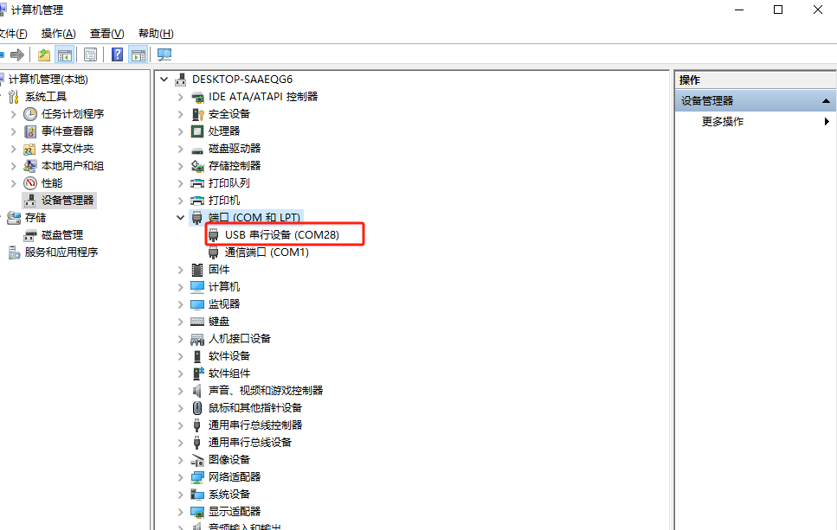

or

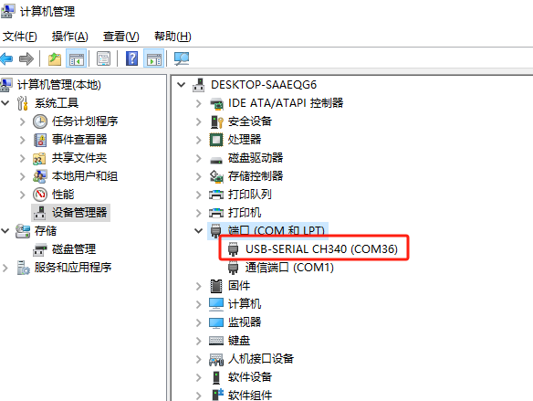

1. The corresponding COM port is displayed here, click on it to modify.

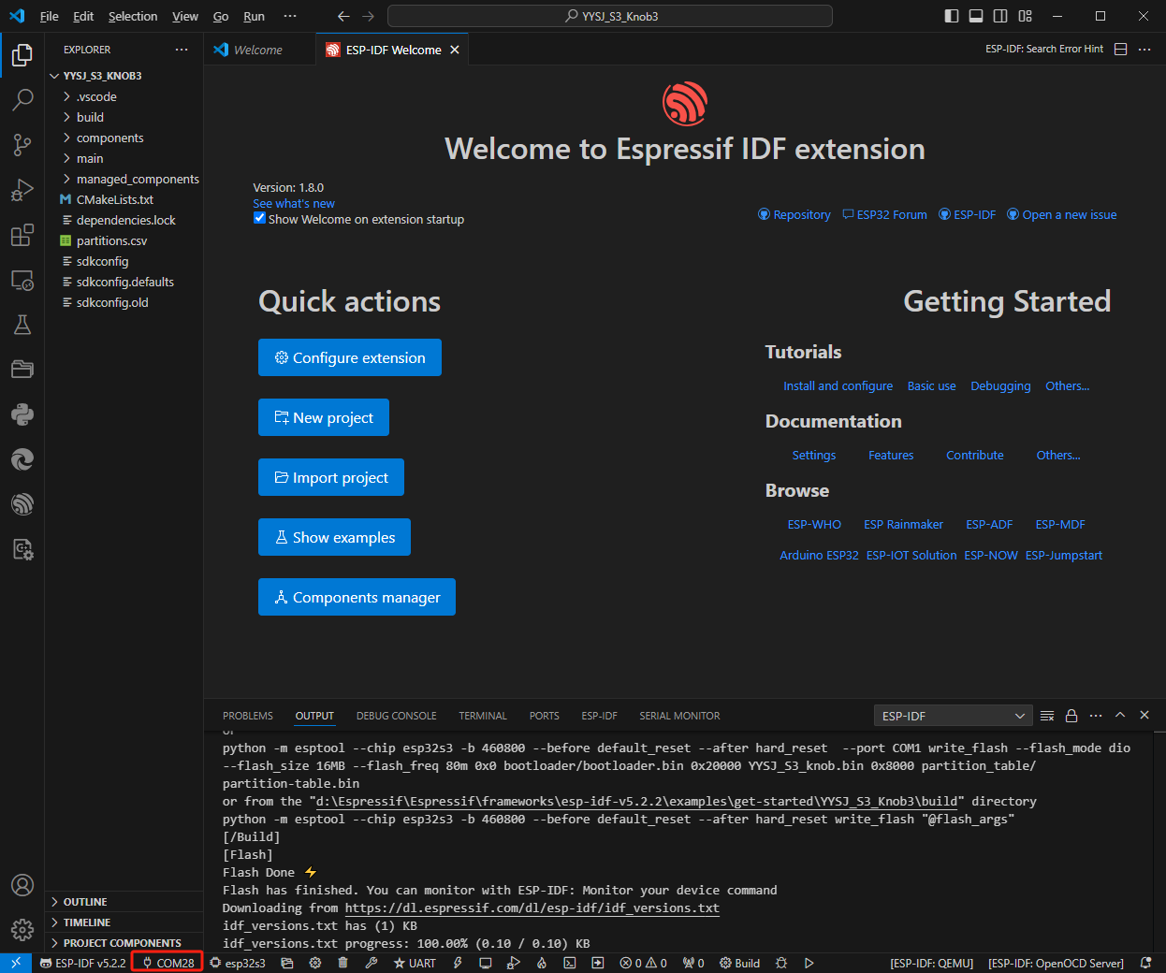

1. We check the device manager COM port, and select COM28, please select your corresponding COM port:

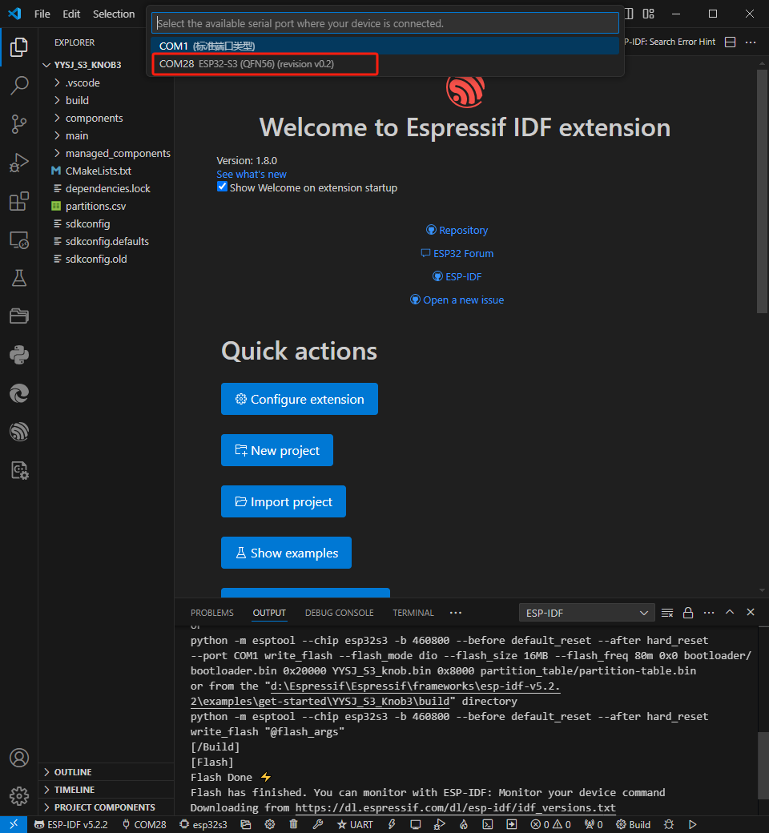

4. Then the COM port is modified.

## Modify the Driver

1. Here shows the driver used, click here to modify the corresponding driver:

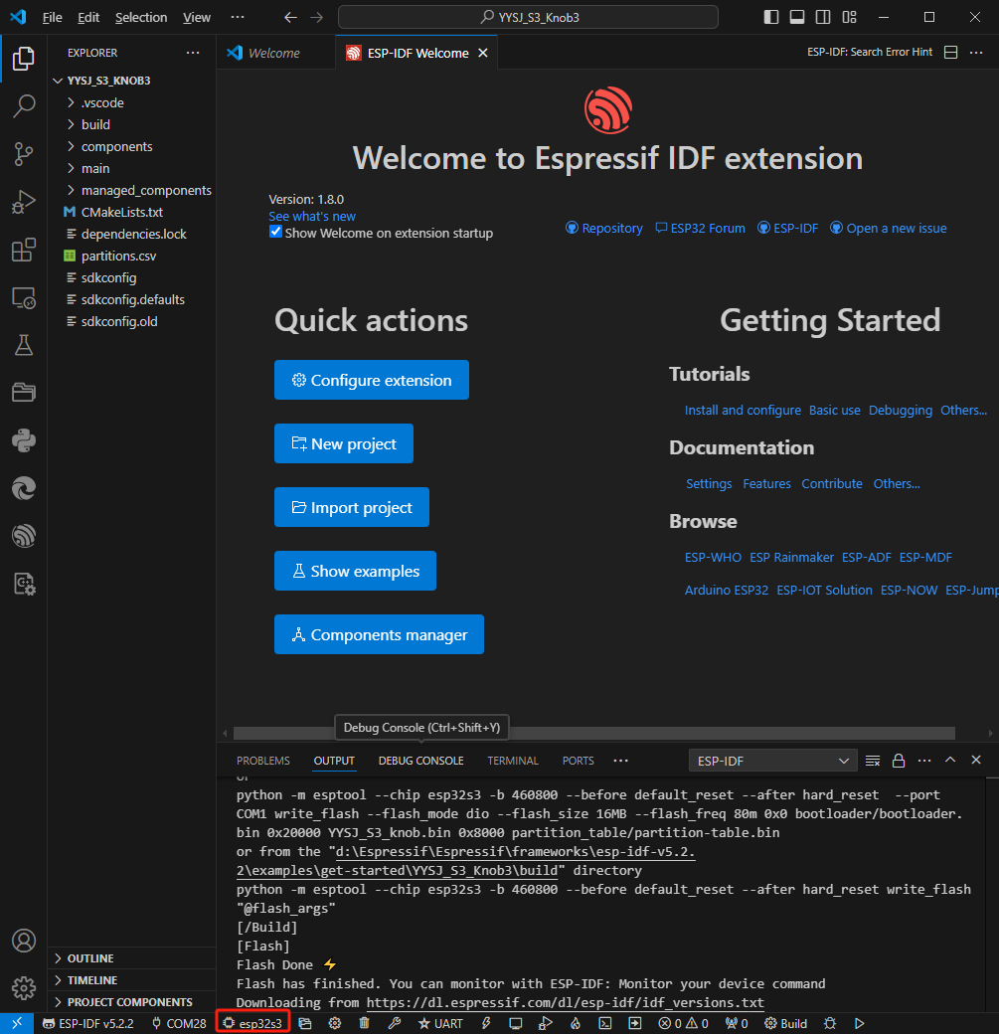

2. Wait for a few seconds after clicking.

[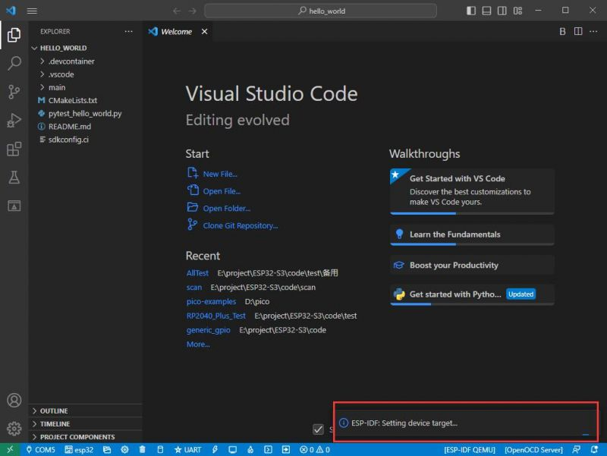](https://www.waveshare.com/wiki/File:ESP32-S3-Pico_27.jpg)

4. Choose the driver we need, that is, the main chip ESP32S3.

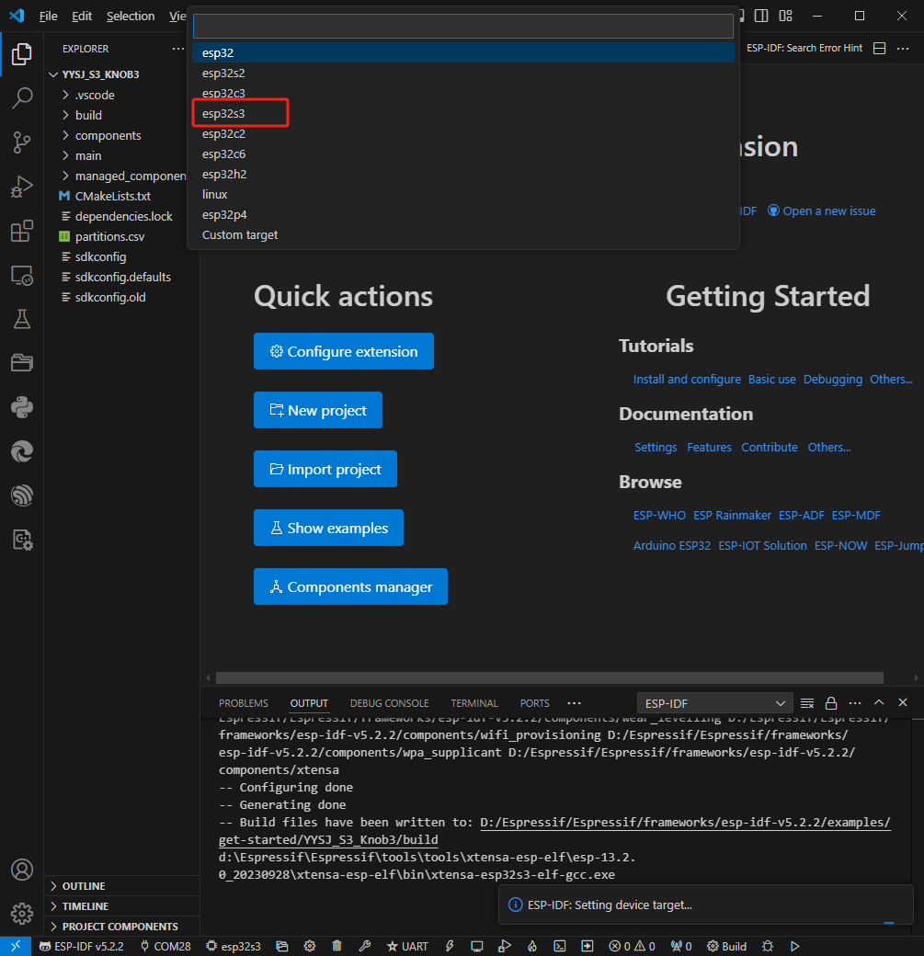

5. Choose the open path, we can just choose one at random as it doesn't matter.

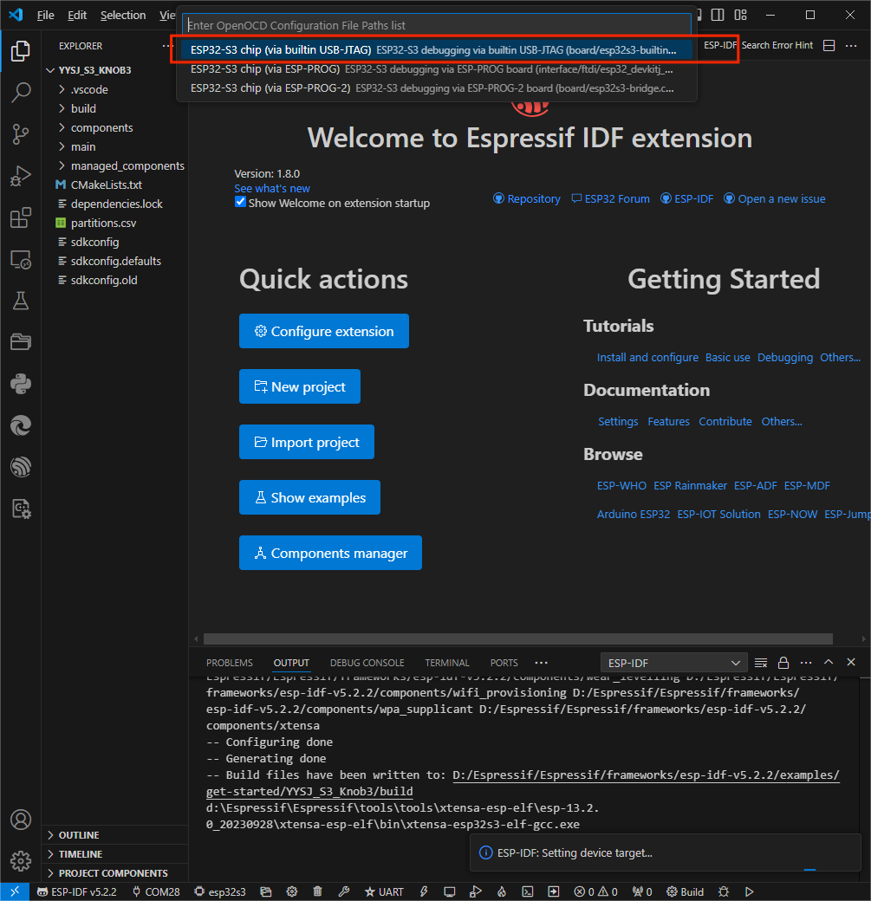

## The Rest of the Status Bar Introduction

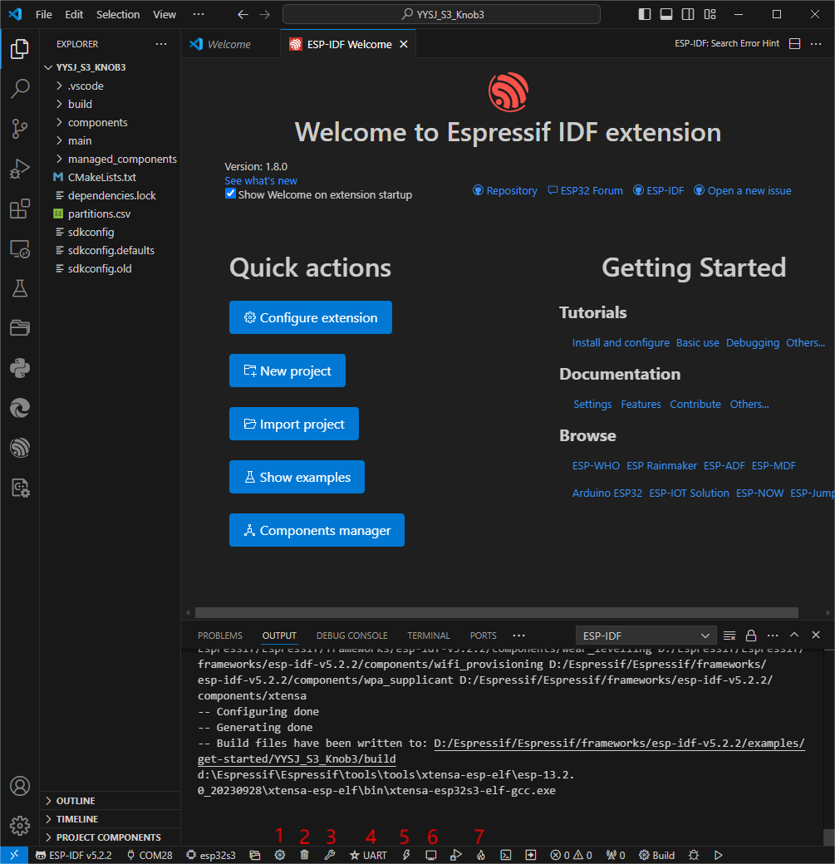

① SDK configuration editor: many functions and configurations of ESP-IDF can be modified within it.

② Clean up everything and delete all compiled files.

③ Compile.

④ Current download method, default is UART.

⑤ Program the current firmware, please do it after compiling.

⑥ Open the serial monitor to view serial information.

⑦ Combined button for compiling, programming, and opening the serial monitor (most commonly used during debugging).

## Compile, Program, and Serial Port Monitoring

1. Click on the Compile, Program, and Open Serial Monitor buttons we described earlier.

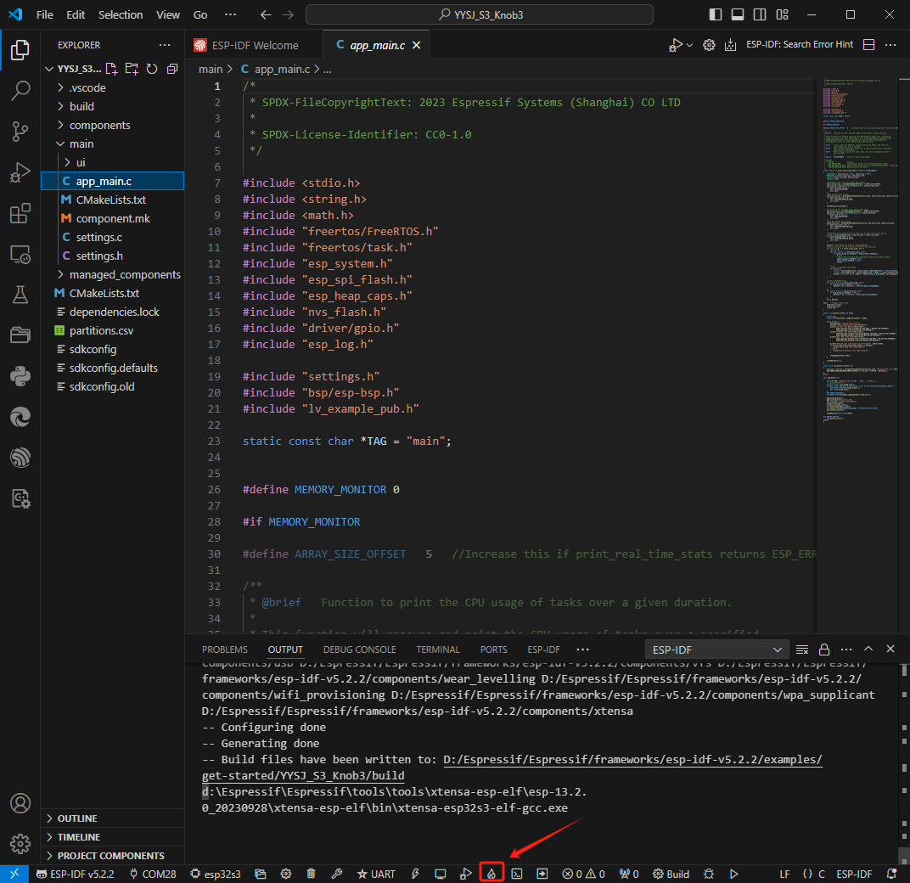

2. It may take a long time to compile, especially for the first time.

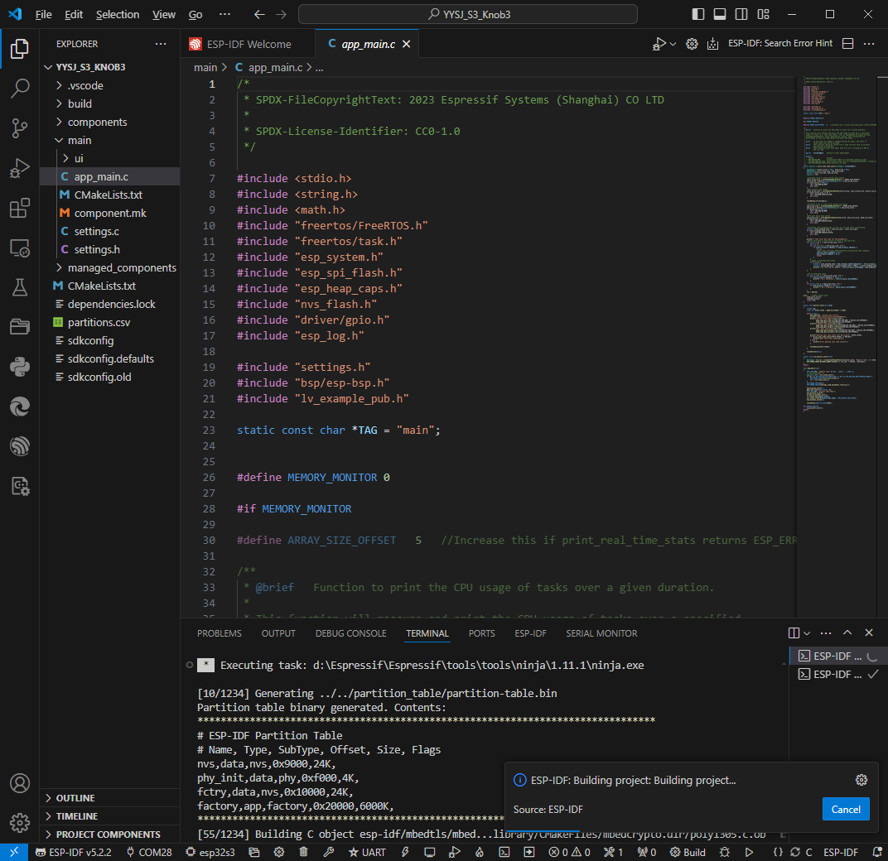

*During this process, ESP-IDF may take up a lot of CPU resources and therefore may cause system lag.*

3. Because we use CH340 as a USB to serial port chip, and the on-board automatic download circuit, it can be downloaded automatically without manual operation.

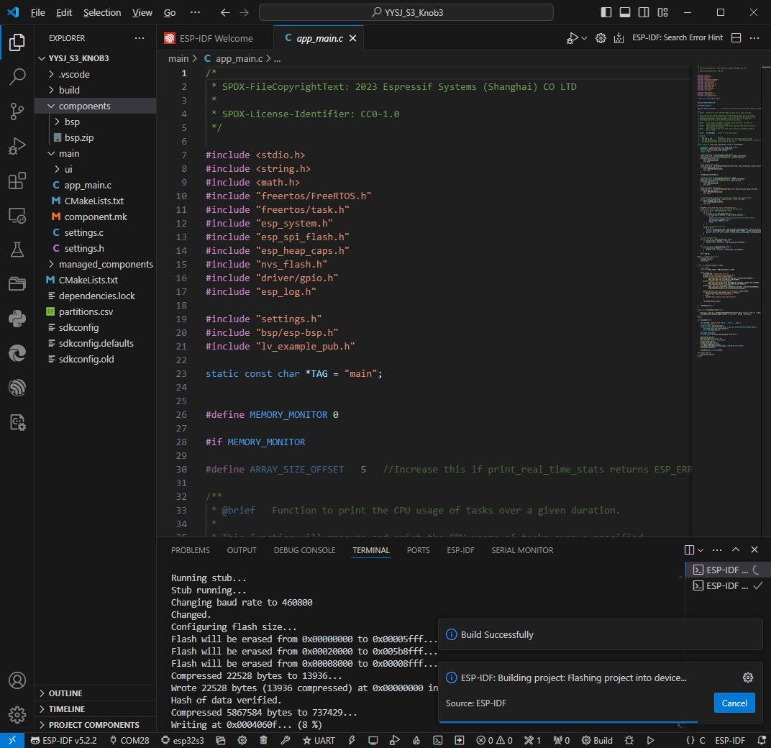

4. After successful download, it will automatically enter the serial monitor, and you can see the corresponding information output from the chip and prompt to reboot after 5s.

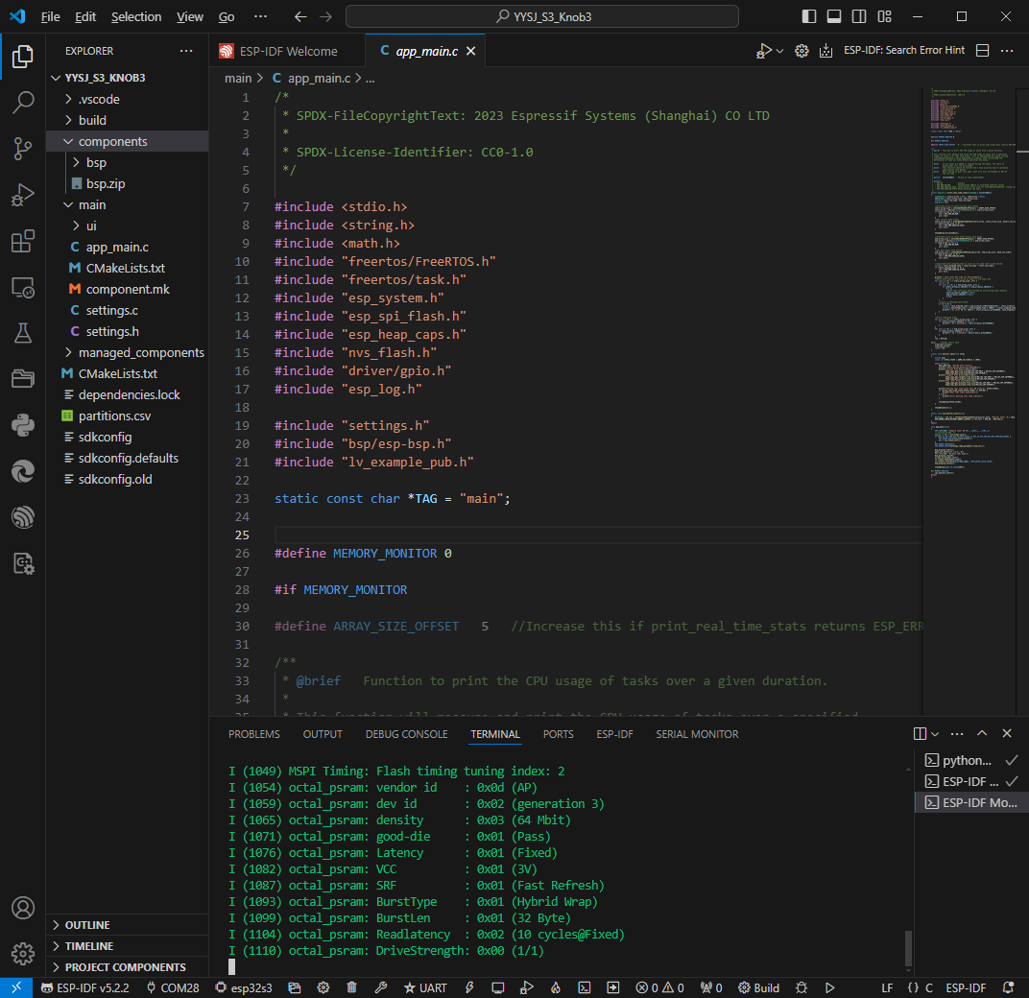

# Software

* [Sscom5.13.1](https://files.waveshare.com/upload/b/b3/Sscom5.13.1.zip)
* [VSCode](https://code.visualstudio.com/download)
* USB to Serial Port Tool
  + [Windows](https://www.wch.cn/download/CH341SER_EXE.html)
  + [LINUX](https://www.wch.cn/download/CH341SER_LINUX_ZIP.html)
  + [Android](https://www.wch.cn/download/CH341SER_ANDROID_ZIP.html)
  + [MacOS](https://www.wch.cn/downloads/CH34XSER_MAC_ZIP.html)
* [ESP32\_S3\_flash\_download\_tool](https://files.waveshare.com/wiki/ESP32-S3-Touch-LCD-4.3B/ESP32_S3_flash_download_tool.zip)